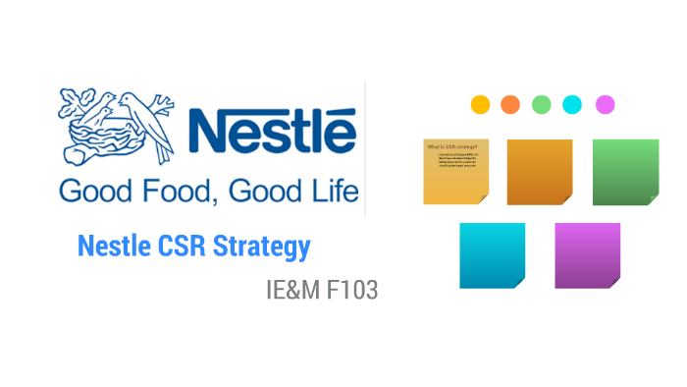

**Module title: Corporate Social Responsibility**

**Module code: CORP5060**

**Assignment title: Evaluating Nestle’s CSR performance**

**Table of Contents**

PART 1. Introduction 1

PART 2. Overview of Nestle and its Corporate Social Responsibility Approach 2

PART 3. Evaluation of Nestle’s CSR Performance 3

3a 3

1. Definition 3

2. Motivation, drivers and pressures 3

3b 4

3. Stakeholder engagement and management 4

7. Sustainable Development Goals (SDGs) 5

PART 4. Conclusion 7

a. Keypoint summarization 7

b. Stages of CSR 7

PART 5. Reflective Commentary 8

Reference 9

# PART 1. Introduction

This essay is prepared to discuss and evaluate the CSR activities of Nestle. The essay is divided into 4 parts. The 1st part consists of an overview of Nestle and its approach toward corporate social responsibility. The 3rd part discusses Nestle’s approach to defining CSR and the motivation that drives Nestle’s commitment to fulfil its CSR. The evaluation also identifies the relationship between its business strategy of Nestle and its sustainability goals. Another part of the evaluation includes discussing reasons Nestle considers SDG and one SDG in which Nestle has contributed and another SDG in which it needs improvement. The concluding section provides a brief summarization of the evaluations done so far and Nestle’s commitment to sustainability in light of Maon et al, (2010) stages of CSR development. The last part includes a reflective commentary.

# PART 2. Overview of Nestle and its Corporate Social Responsibility Approach

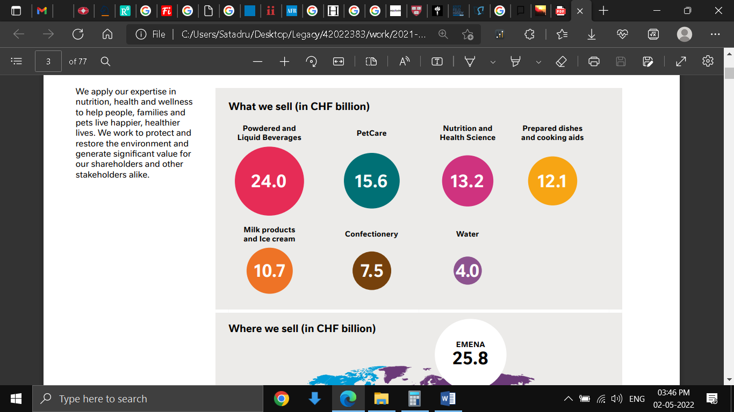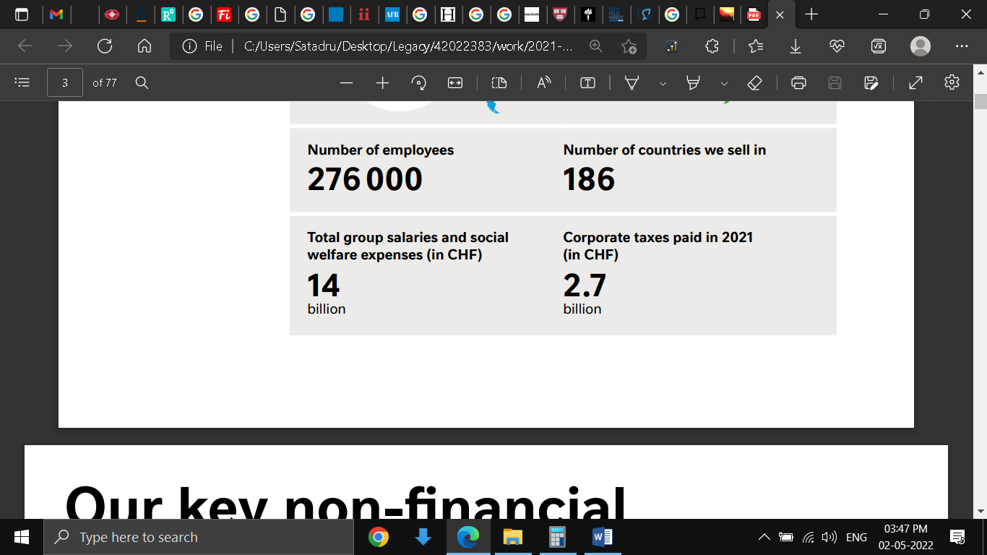

Fig 1: Quick overview of Nestle

(Source: Nestle Report, 2021)

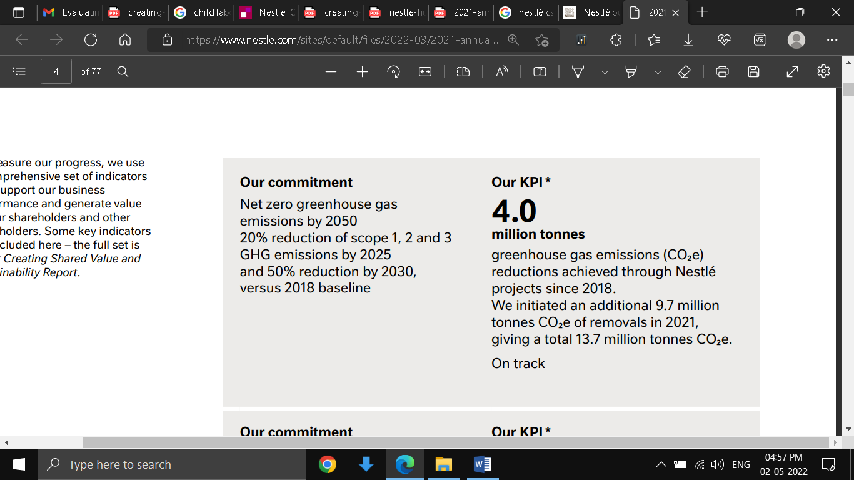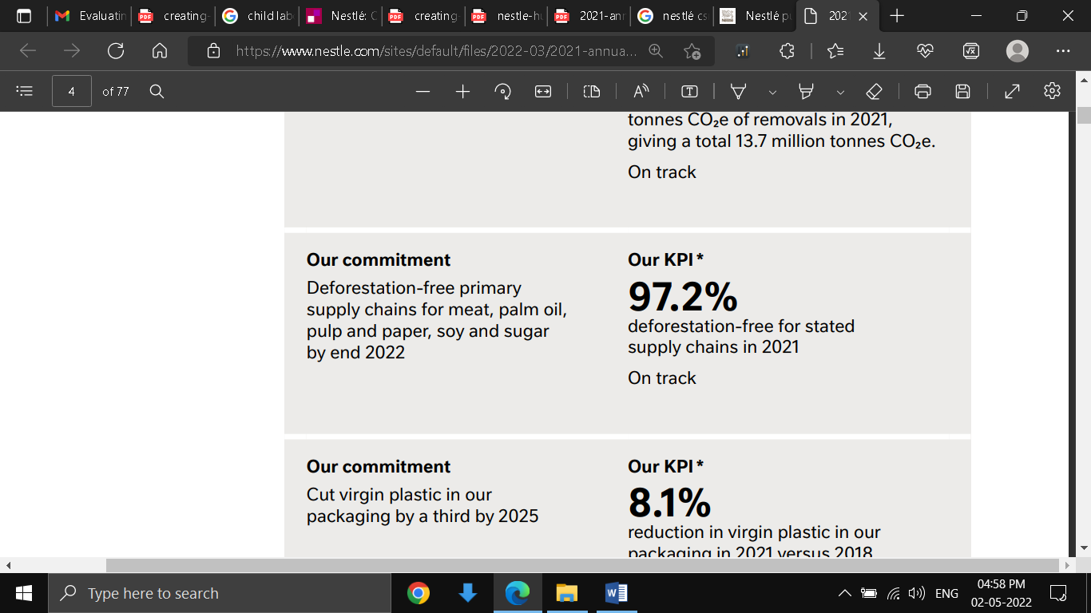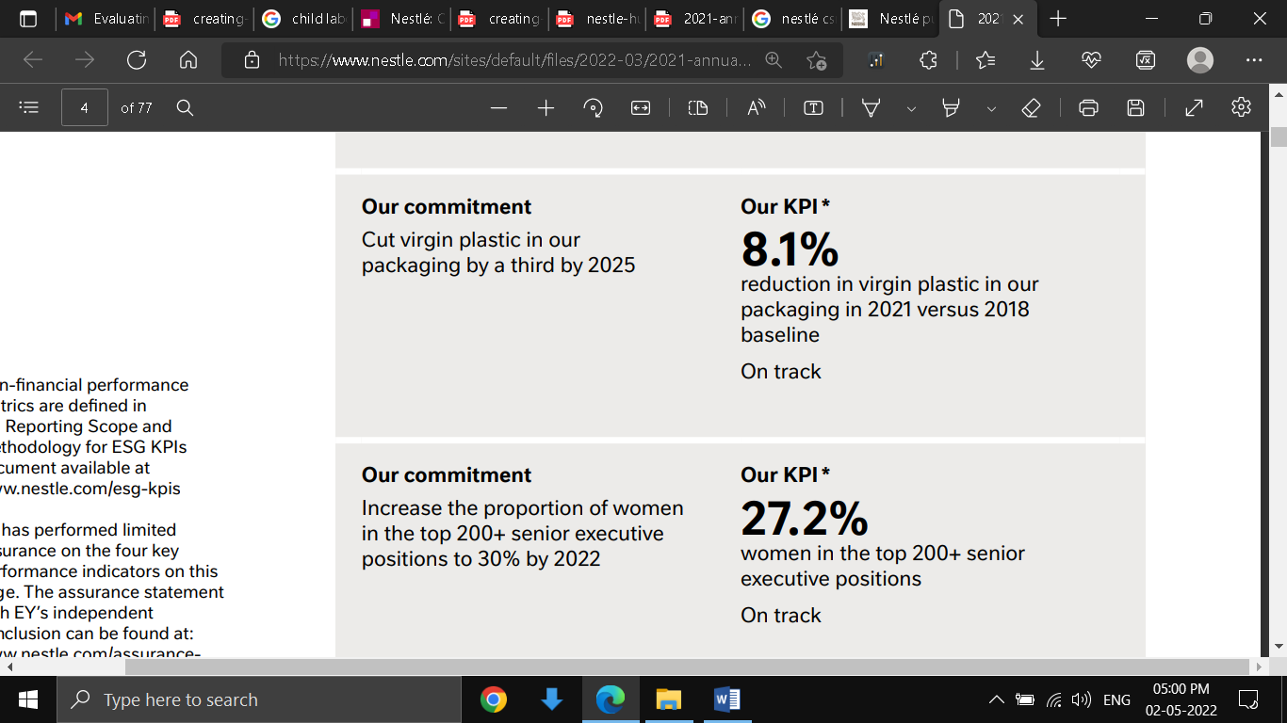

Fig 2: Non financial KPI of Nestle

(Source: Nestle Report, 2021)

Nestle is a multinational company spread across 186 countries all over the world. It sells products such as powdered and liquid beverages, pet care, prepared dishes and cooking aid, milk products and ice cream, confectionery items, and water as well as, nutritional and health science products. It has an employee strength of 276000 comprising all global locations. According to the annual report of Nestle, the total group salaries and social welfare expenses comprise in 2021 amounted to CHF 14 billion and corporate taxes paid were CHF 2.7 billion (Nestle Report, 2021). Some of the key indicators of Nestle’s progress that supports the business and generate value are 4.0 million tonnes of reduction of greenhouse gas emission since 2018. Nestle also started removal of additional 9.7 million tonnes of carbon dioxide in 2021, which brings a total reduction of 13.7 million tonnes of the gas so far. Nestle also achieved a 97% deforestation-free for selected supply chains in 2021 (Nestle Report, 2021). Plastic use in 2021 in packaging and other related operation reduced by 8.1% compared to 2018.

The corporate social responsibility approach of Nestle is based on the theme of ‘Creating shared Value’ through which Nestles aims to unlock the power of food to improve the quality of life for everyone, for both the present and future generations. Some of the broad outlines of Nestle’s CSR activities include a contribution to nutritious and sustainable diets, lending support to protect, restore and renew the natural resources, strengthening the communities and operating responsibly. By helping to protect and restore natural resources, Nestle aims to minimize its operational impact on natural resources. Natural resources cannot be renewed and revived quickly and thus Nestle aims to reduce dependency on natural resources through activities such as the regeneration of the local water cycle. To this effect, Nestle has decided to launch 100 projects in total spread across 48 different sites where water regeneration is feasible by the year 2025 (Nestle Report, 2021). By operating responsibly Nestle aims to increase employee health and well-being, through processes like talent management, employee relations and engagement. The CSR initiatives of Nestle thus cover a broad spectrum such as nature and its resources, the community’s well-being and employee wellbeing.

# PART 3. Evaluation of Nestle’s CSR Performance

3a**.**

### 1. Definition

As pointed out in section 2 about the broad spectrum of Nestle’s CSR activities, it is evident that Nestle’s approach to defining corporate social responsibility is, ‘Creating Shared Value” by catering to the needs of both nature and the people. Creating shared value is the main goal in all and every business strategy. Nestle aims to build long term value for both the society and the shareholders. Nestle understood the need to create a regenerative food system that can help Nestle increase the quality of life for everyone and achieve its commitment to reduce greenhouse gas emissions. To advance the progress of the regenerative food system, Nestle invests to the tune of CHF 1.7 Billion every year in R&D works. Some of the progress made by Nestle in this aspect is a reduction of 5.1% in added sugar in products, and a total of 207.4 billion servings with micronutrient fortification. Apart from creating a regenerative food system, Nestles other areas of commitment in CSR activities include the preservation of natural resources such as water, nature and biodiversity. Efficient water resource management is carried out across operational and agricultural supply chains. Nestle is committed to planting 200 million trees by 2030. To strengthen the community with whom Nestle works, the growers and the environment in which they work are protected through sustainable and resilient food supply chains.

### 2. Motivation, drivers and pressures

Nestlé’s commitment to CSR is driven by the motivation for the creation of a sustainable environment for the future generation. Nestle understands that its involvement in food production is invariably connected to the environment and the people dependent upon that environment. Agriculture when done on a commercial basis can degrade the soil and cause salination of soil which also affects the nearby water bodies. This is why Nestle insisted on creating an organic agriculture model. This insistence on practising organic agriculture is again related to the regenerative food system of Nestle (Nestle Sustainability, 2021). A regenerative food system is a holistic approach to cater to the needs of both the ecosystem and the people such as farmers, producers, fishers and others dependent upon that ecosystem and reverse the effect of climate change (Zhongming and Wei, 2021).

The other initiatives of Nestle such as the protection of community and biodiversity stem from the same motivation of creating a sustainable environment for the future. Some of the key indicators that act as motivational factors for Nestle to carry on its CSR activities are 2.30 million cubic metres of reduced water usage in factories, total water withdrawal in all areas decreased from 115 million metric cubes per year in 2020 to 98 million metric cubes per year in 2021. Initiatives for community development has helped the farmers create resilient business and earn a living income. This suggests that rural development and livelihood transformation are the key agendas in Nestle’s long term commitment to the community. To introduce environmentally sustainable practices for the suppliers and producers, Nestle introduced changes in its procurement program. This saw a change in the ways 14 key agricultural raw materials are sourced, which covers 95% of the annual sourcing by volumes such as coffee, cocoa, dairy, sugar, cereals and grains. This change led to 16.3% of key ingredients being produced sustainably (Nestle Sustainability, 2021). The result of this effort is making the supplier of the raw agricultural materials accountable for social and environmental improvement.

3b**.**

### 3. Stakeholder engagement and management

Fig 3: Stakeholders participants of Nestle

(Source: Nestlé Stakeholder Engagement, 2022)

The stakeholders with whom Nestle engages are academicians, communities, consumers and the general public, customers, employees and their representatives, and governments. Apart from these the other important stakeholder’s are industry and trade associations, intergovernmental organisations, non-governmental organisations, reporting agencies, shareholders and the financial community and suppliers (which includes farmers and smallholders) (Nestlé Stakeholder Engagement, 2022).

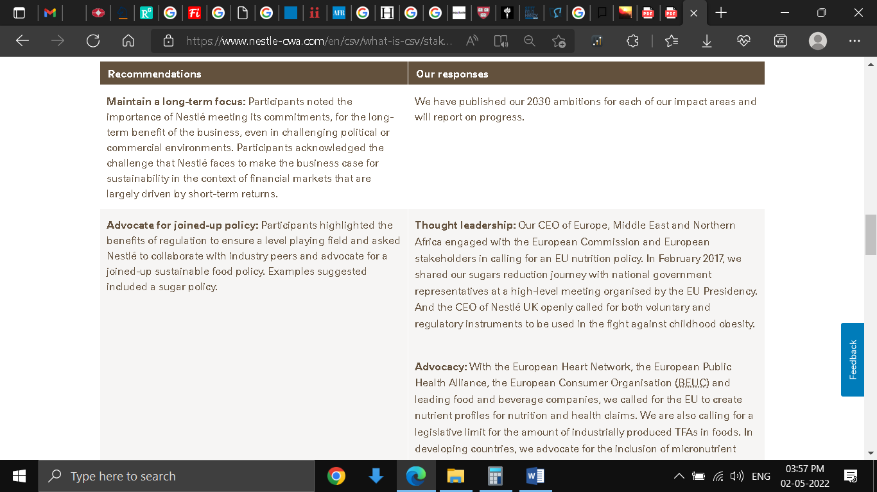

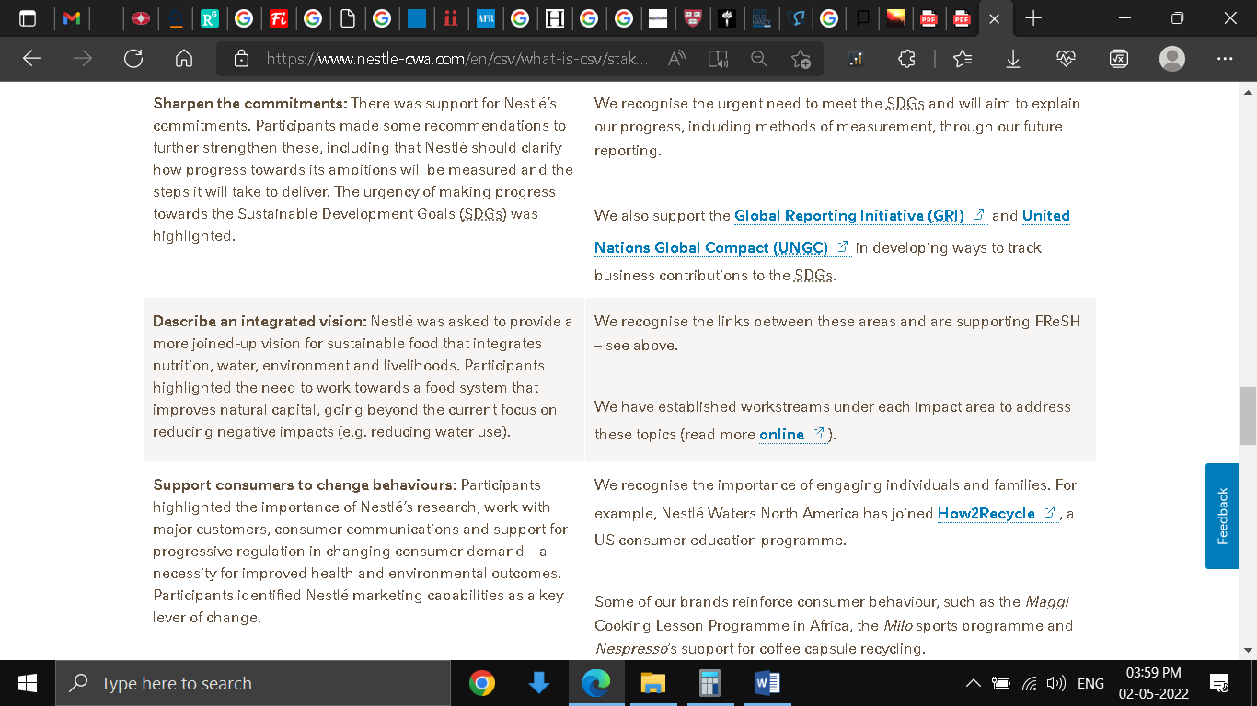

Fig 4: Recommendations by Stakeholders and actions taken by Nestle

(Source: Nestlé Stakeholder Engagement, 2022)

Nestle understand the importance of stakeholder engagement because the advice that is received from them helps Nestle shape the corporate policies and other business decisions and strengthen Nestle’s societal investments. Their advice and expertise help Nestle to tackle CSV (Creating Shared Value) issues such as (health and nutrition, rural development, water conservation and usage, human rights environmental sustainability) that arise in due course of its operations. Apart from this, another factor that Nestle takes into account while engaging with stakeholders is its relationship with Nestle and their knowledge and experience of important Nestle markets (Espinoza-Orias et al., 2018). Engagement with stakeholders is important for Nestle because the advice received from them has helped Nestle improve its operations. For example, recommendations were made through stakeholder meetings on the joined-up policy. This joined-up policy will help Nestle advocate sustainable food policy by collaborating with industry peers. In response to this advice, Nestle formed a thought leadership where the CEOs in Europe, the Middle East and Northern Africa collaborated with the European stakeholders and the European Commission to form a sustainable EU nutrition policy. This in turn resulted in a joint sugar reduction initiative with national government representatives (Nestlé Stakeholder Engagement, 2022).

The approach adopted by Nestles to engage with stakeholders can be called a normative approach. In the normative approach, the stakeholders are not simply a means to obtain a certain financial advantage. Here all members of the stakeholder group have equal importance for their contribution (Bester, 2021). This is evident from the fact that Nestle gives equal importance to every member of the stakeholder group to shape the future policies and outcomes of the organization.

7. Sustainable Development Goals (SDGs)

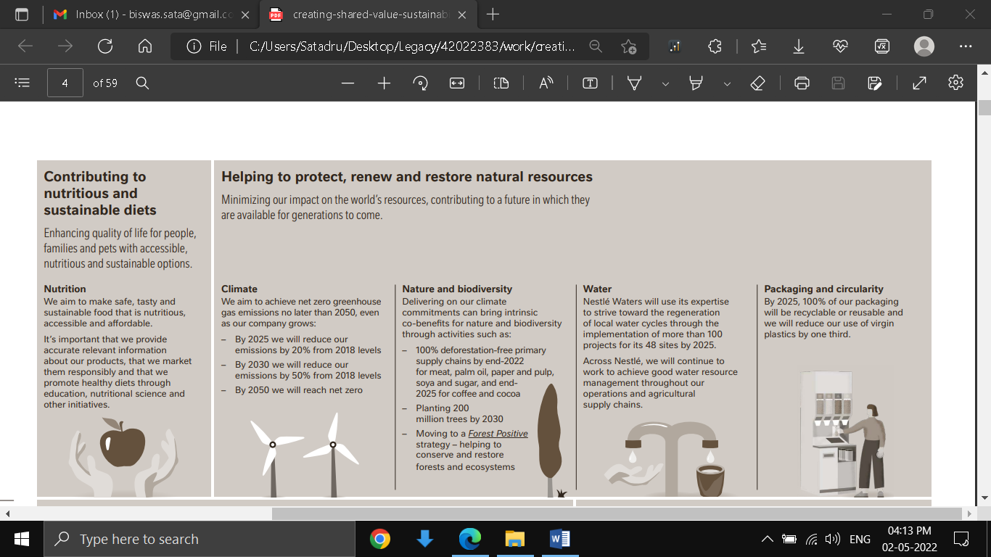

Fig 5: Nutrition and climate as part Nestle’s SDG

(Source: Nestle Sustainability, 2021)

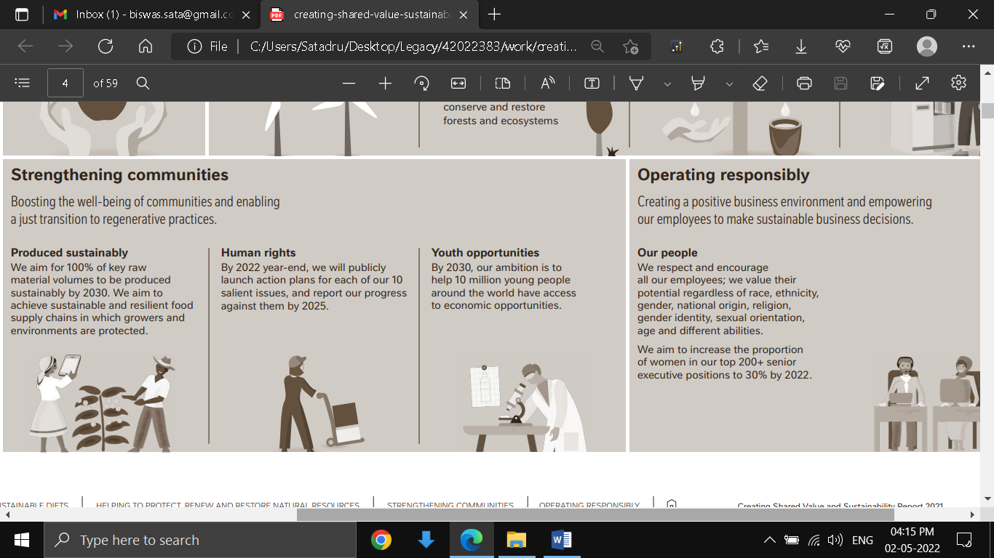

Fig 6: Community and operating responsible as part Nestle’s SDG

(Source: Nestle Sustainability, 2021)

Nestles understands the importance and gives due recognition to sustainable development goals because Nestle believes that creating shared value is fundamental to the way the business operates (Nestlé Goals, 2022). Nestle’s insistence on following SDG also stems from the fact that the company believes that it can be successful in the long run only if it can create value for both the shareholders and society. Another reason for Nestle’s recognition of SDG is the fact that ‘Creating Shared Value” which is Nestle’s very own term given to its sustainable goals is framed in light of the United Nations 2030 Agenda for Sustainable Development Goals. The integration of Nestles own “Creating Shared Value” with UN’s SDG goals has helped the company identify the important areas in which Nestle has the potential to create a sustainable positive impact or nonetheless reduce the negative impact as far as possible. Another reason for Nestle’s increased recognition of the SDGs because it helped the company map material issues to the global goals. This in turn helped Nestle find the activities that contributed the most to meeting its aim (Nestlé Goals, 2022).

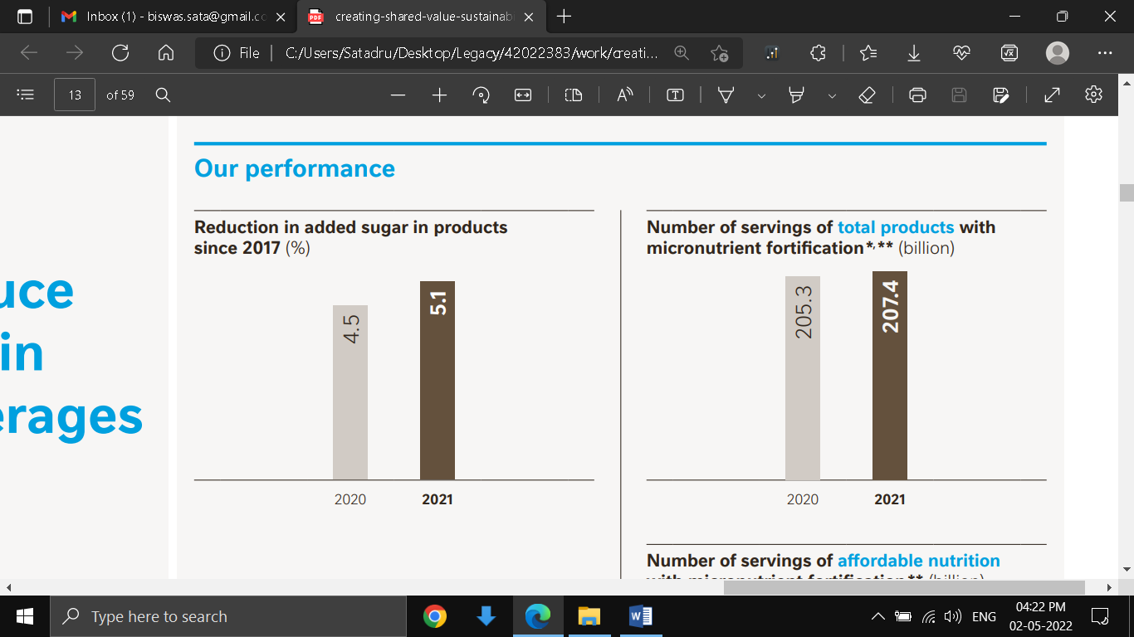 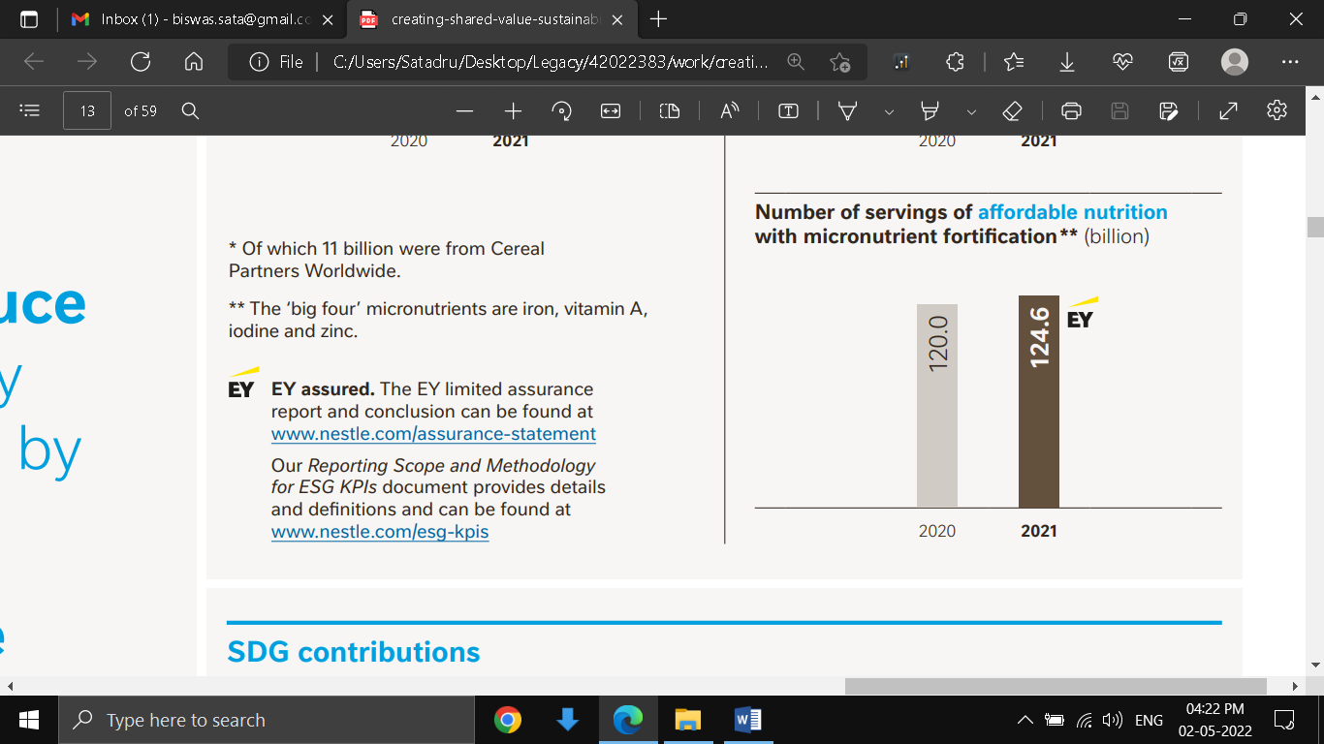

Fig 7: Good Health and Wellbeing as Nestle’s SDG

(Source: Nestle Sustainability, 2021)

One SDG in which Nestle has contributed effectively is Zero Hunger by applying the Popularly Positioned Products (PPP) Affordable Nutrition strategy. This strategy helped Nestle to provide affordable and accessible nutrition for lower-income consumers. This strategy is mainly followed in developing economies. By utilising the global expertise and footprint along the value chain and research and development, Nestle was able to cater for a wide array of products and services to the local consumer. In this way the nutritional needs and tastes, both were fulfilled for the local consumers within comfortably affordable limits, of $2-$4/day (Nestle Sustainability, 2021). These offers mainly included items that are consumed regularly and available widely, such as porridges and dairy products. Besides fulfilling the nutritional values, many of the affordable products also covered the vitamin deficiency in the consumers through micronutrient fortification.

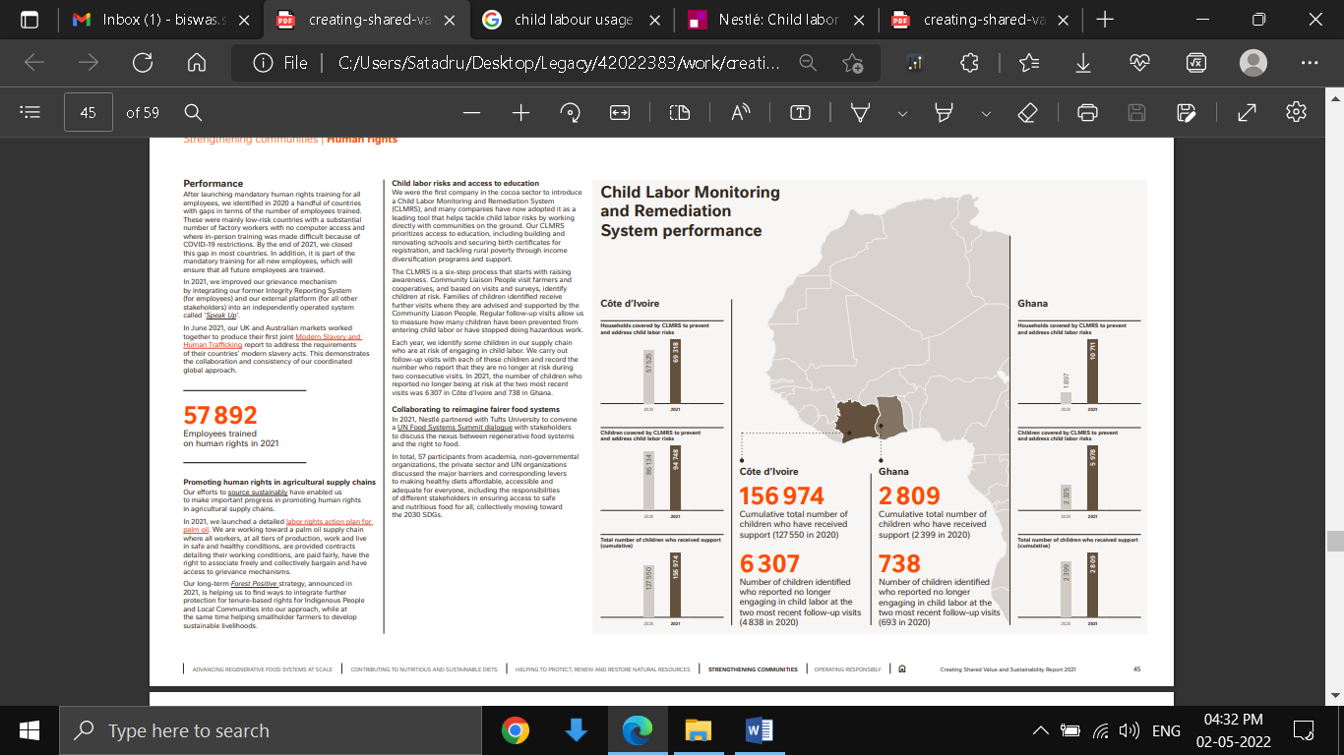

Fig 8: Child labour monitoring statistics

(Source: Nestle Sustainability, 2021)

Despite having a broad coverage of various SDGs, there are still issues plaguing Nestle with the Human Rights Framework and Roadmap, regarding the use of child labour (Nestle Sustainability, 2021). Despite having sufficient well-formulated guidelines such as Child Labour Monitoring and Remediation System, there are issues with child labour usage pending lawsuits in the US (Nestle Human Rights Framework, 2021). Instances where child labour is employed and exploited in cocoa plantations in Ivory Coast, a West African country, have come to the forefront (Balch, 2021). This onis e of the critical areas of SDG that is still lacking even after taking preventive measures like launching the CARE Audit Protocol, publishing reports on labour risks and recently improving the internal grievance mechanism system. Thus this is one area in which Nestle needs considerable improvement.

# PART 4. Conclusion

## a. Key point summarization

The evaluation pointed out that, Nestle’s CSR is based on the theme of “Creating Shared Value”. Nestles motivation to follow its CSR rises from its concern about its environmental impact on future generations. To this effect, Nestle has aligned its own sustainable development goals under “Creating Shared Value” with the 17 UN SDGs. Nestle understands the importance of working with stakeholders, to shape its policies and goals to reach its SDGs. For this reason, it engages with a multitude of stakeholders ranging from governmental agencies, inter-governmental organisations and academicians. Nestle has excelled well in meeting one of its SDGs, of zero poverty although it still needs improvement in matters related to human rights and child protection.

## b. Stages of CSR

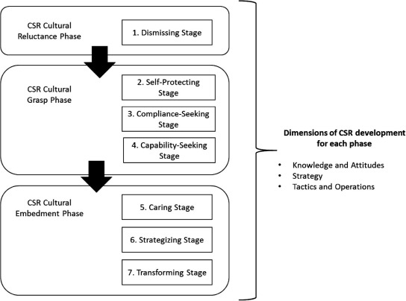

Fig1: Stages of CSR development

(Source: Wells et al., 2016)

Nestle’s commitment to following through with its CSR seems to fall between level 6 which is the Strategic Stage and level 7 which is the Transformative Stage. This is because although Nestle has incorporated CSR activities in every aspect of it operations where culture and strategy are based on human wellbeing and ecological sustainability, there are still major issues left unfixed. These are with regards to human rights violations in child labour usage. Besides that, it is only in recent years that CSR activities are formulated with human wellbeing and ecological development in focus. So, it will still take some time for Nestle to completely transform its CSR culture into a level 7 Transforming Stage.

# PART 5. Reflective Commentary

Through the course of this module, I have learned to delve deep and read in-between the lines of Sustainability Reports or Annual Reports of companies such as Nestle. I have learnt the different ways through which Nestle carries out their sustainable development goals. The key performance indicators help to understand milestones reached in attaining its sustainable development goals. After studying the business strategies applied and sustainable development goals formulated, I found a close link between the two. I have also learnt how stakeholders from different parts of the society come and join hands to attain the common goal of human and environmental development with Nestle. And ways in which stakeholder engagement helped Nestle form future policy and decisions. For example stakeholder’s advice for advocating sustainable food policy, was followed by Nestle and the end result was seen in the reduction of sugar in its food products. I also learnt how Nestle helped to bring change and reverse the environmental damage caused due to years of negligence through the adoption of a regenerative food system. I have also learnt why it becomes important to link a business organisation’s SDG with that of globally recognized development programs carried out by the UN. This helps to have clarity about the present state of its development goals. I also learned about benchmarking ranks made available in sustainability reports, which helps to understand the current position of Nestle in a certain area of its SDG in comparison to other organisations.

I also learnt that sustainability reports or Annual reports are sometimes not enough to truly evaluate the effectiveness of the CSR activities carried out by business organisations. Because the compliance section or the risk assessment section will not cover in detail matters that violate ethical principles. I found this in the case of Nestlé’s reports. This is because there are only mentions of facts, figures and statements of initiatives taken and milestones achieved. There is no mention of statements that indicated Nestle’s failure to follow through with its promises in CSR. This became evident when I came across reports in electronic media such as press releases by whistle-blowers about incidents of child labour in the West African country, Ivory Coast. Thus this is another important lesson I learnt, to compare and tally the statements and facts given by big organisations like Nestle with news and articles from another neutral 3rd party source. For this reason, I think Nestle is in level 6 Strategizing Stage of the Embedment Phase.

# Reference List

Balch, O., (2021). Mars, Nestlé and Hershey to face child slavery lawsuit in the US. [online] the Guardian. Available at: <https://www.theguardian.com/global-development/2021/feb/12/mars-nestle-and-hershey-to-face-landmark-child-slavery-lawsuit-in-us> [Accessed 29 April 2022].

Bester, T.V., (2021). Corporate Sustainability and the Sustainable Development Goals: Respect for Civil Rights in Business. Sustainability Science and Resources, 1(1), pp.1-37. [online] Available at:< http://journalssr.com/index.php/ssr/article/view/1/46> [Accessed 29 April 2022].

Espinoza-Orias, N., Cooper, K. and Lariani, S., (2018). Integrated product development at Nestlé. In Designing Sustainable Technologies, Products and Policies (pp. 447-456). Springer, Cham. [online] Available at: <https://library.oapen.org/bitstream/handle/20.500.12657/23005/1007156.pdf?sequence=1#page=427> [Accessed 29 April 2022].

Nestlé Goals. (2022). Contributing to the global goals. [online] Available at: <https://www.nestle-cwa.com/en/csv/what-is-csv/contributing-to-the-global-goals> [Accessed 29 April 2022].

Nestle Human Rights Framework. (2021). Nestlé’s Human Rights Framework and Roadmap. [online] Available at: <https://www.nestle.com/sites/default/files/2021-12/nestle-human-rights-framework-roadmap.pdf> [Accessed 29 April 2022].

Nestle Report. (2021). Nestle Annual Review. [online] Available at: <https://www.nestle.com/sites/default/files/2022-03/2021-annual-review-en.pdf> [Accessed 29 April 2022].

Nestlé Stakeholder Engagement. (2022). Stakeholder engagement. [online] Available at: <https://www.nestle-cwa.com/en/csv/what-is-csv/stakeholder-engagement-new> [Accessed 29 April 2022].

Nestle Sustainability. (2021). Nestle Sustainability Report. [online] Available at: <https://www.nestle.com/sites/default/files/2022-03/creating-shared-value-sustainability-report-2021-en.pdf> [Accessed 29 April 2022].

Wells, V.K., Smith, D.G., Taheri, B., Manika, D. and McCowlen, C., (2016). An exploration of CSR development in heritage tourism. Annals of Tourism Research, 58, pp.1-17. [online] Available at: < https://www.sciencedirect.com/science/article/pii/S0160738316300093#b0235> [Accessed 29 April 2022].

Zhongming, Z. and Wei, L., (2021). Nestlé unveils plans to support the transition to a regenerative food system. [online] Available at: <http://resp.llas.ac.cn/C666/handle/2XK7JSWQ/338021> [Accessed 29 April 2022].